
A Summary of the Report Examining the Impact of the Economic Downturn on Voluntary Disability Organisations in Ireland

INTRODUCTION
The purpose of the DFI research was to examine the impact of the economic downturn on voluntary disability organisations and their service users. As main providers of direct health and social services to people with disabilities, DFI wanted to know what impact, if any, the recession has had on funding for disability services. A survey examining opportunities as well as challenges arising from the recession was circulated to 120 DFI member organisations in July 2009, and approximately 60% of organisations responded to the questionnaire. This provides a meaningful representation of the DFI membership. A summary of the findings from the survey are outlined here. We encourage our members to use these findings in your pre-budget submissions.

A PROFILE OF DFI MEMBERSHIP
The disability sector is diverse and DFI member organisations tend to represent people with one or more disability, across physical, sensory, intellectual, emotional, neurological and mental health sectors. The range of services provided by voluntary disability organisations is demonstrated in the Table below, with advocacy and support work proving to be a key element of their work, as well as training, education, independent living support, medical and social services.

Table 1 Activities of Organisation

Organisation Activities | Percentage
Aids and Appliances | 18%
Respite care services | 31%
Helpline/telephone support | 54%
Family support worker | 27%
Personal Assistant hours | 28%
Assessments | 19%
Training and support | 52%
Day care services | 19%
Newsletter | 58%
Advocacy work | 67%
Accommodation and residential services | 24%
Information on websites | 52%
Support groups | 48%
Other | 46%

FUNDING VOLUNTARY SERVICES FOR PEOPLE WITH DISABILITIES
The question emerges as to how these services are funded, and the answer largely depends on the size of the organisation. As can be seen in the Chart below, over half of income for small to medium sized organisations (0-24 staff) comes from non-statutory sources such as fundraising, while the bulk of funding for larger organisations, particularly those with over 1000 staff members, comes from statutory sources. However, it should be noted that very large organisations provide direct health and social support on behalf of the State such as accommodation, day services, training and employment services, and they provide in the region of €46 million in additional funds to support these activities. Overall, eight out of ten organisations received some funding from the HSE, while FAS (37%), Pobal (27%) and CRAGA (22%) were the other main sources of statutory funding.

Chart 1 Statutory and Non-Statutory Income as a Proportion of Total Income in 2008 by Size of the Organisation

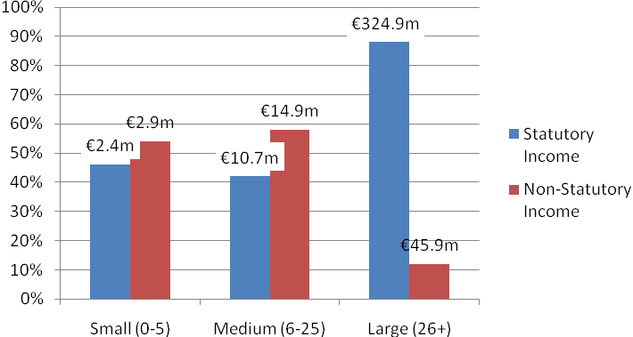

THE EXTENT OF THE IMPACT OF THE RECESSION ON DFI MEMBERS
The majority of the DFI members who responded to the survey reported that they have been affected by the recession. In fact, over three quarters reported that their organisation had been either ‘very significantly’ or ‘significantly’ affected by the economic downturn. This is demonstrated by Table 2 below.

Table 2 Impact of the Economic Downturn on DFI Member Organisations

Response
Percent
Very significantly | 18%
Significantly | 59%
Not Significantly | 22%
Not at all | 1%
N- 68

IMPACT ON SERVICE DELIVERY FOR PEOPLE WITH DISABILITIES
DFI wanted to examine how the economic downturn is impacting on the organisations service delivery to people with disabilities. Chart 2 demonstrates the extent to which voluntary services have been restricted as a result of the recession.

Evidence from the chart clearly shows that the way services are delivered and the development of new services has been affected. For instance, two thirds of respondents stated that they have had to ‘freeze the development of existing services’ which can have a significant impact on the services available to people with disabilities. A further 51% have delayed new service programmes in 2009 while over half of those who had planned capital projects had to delay them as a result of the economic downturn. Furthermore, the majority of those who provide emergency placements for people with disabilities had to use existing funding intended for other services. Given that these figures do not take into account further cuts in 2010, one can imagine that the situation has actually deteriorated in 2010 rather than improved.

Other cost cutting measures introduced by organisations was to restrict staff travel (81%), to not replace staff who have left (60%) and to restrict agency staff where applicable (62%). All of these restrictions can lead to negative impact for service delivery to people with disabilities.

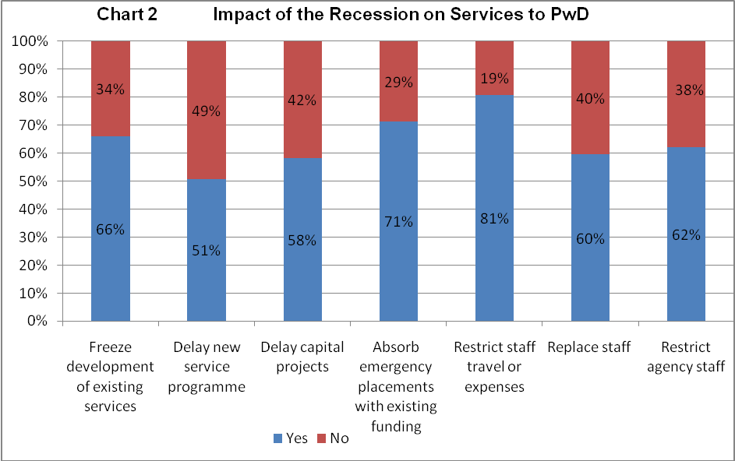

IMPACT OF THE RECESSION ON ORGANISATION FUNDING
Funding for voluntary disability organisations has been significantly affected by the economic downturn. Chart 3 shows that just over three quarters (76%) of respondents stated that the level of their organisations income has decreased in 2009 compared to the previous year.

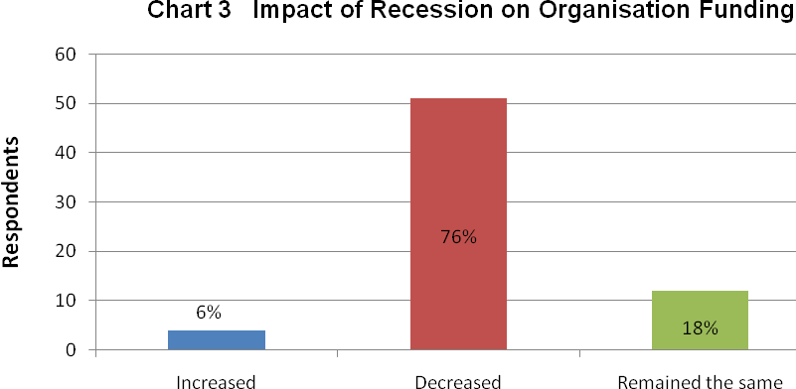

The survey found that organisation statutory and non-statutory funding has been badly affected as a result of the economic downturn. Eight out of ten organisations reported cuts to HSE funding. Furthermore, Table 3 shows the extent to which organisations have experienced a decrease in their level of non-statutory funding. For instance, nine out of ten organisations reported that corporate sponsorship was down on the previous year, and eight out of ten reported the same trend with regard to fundraised and philanthropic income.

Table 3 Extent to which Non-Statutory Income has Increased or Decreased in 2009 compared to previous year

 | Non-Statutory Funding Increased | Non-Statutory Funding Decreased
Fundraised Income | 14% | 86%
Earned Income | 23% | 77%
Philanthropic Income | 15% | 85%
Corporate Sponsorship | 6% | 94%

It is not surprising to find that non-statutory funding has been negatively affected by the economic downturn. Analysis of our open ended questions suggest that the organisations have found that the general public have ‘less to give’ while traditional corporate sponsors such as financial institutes have been hit very badly by this recession. Chart 4 demonstrates how organisations have responded with over two thirds stating that they have had to increase their efforts to generate their total income in comparison to previous years.

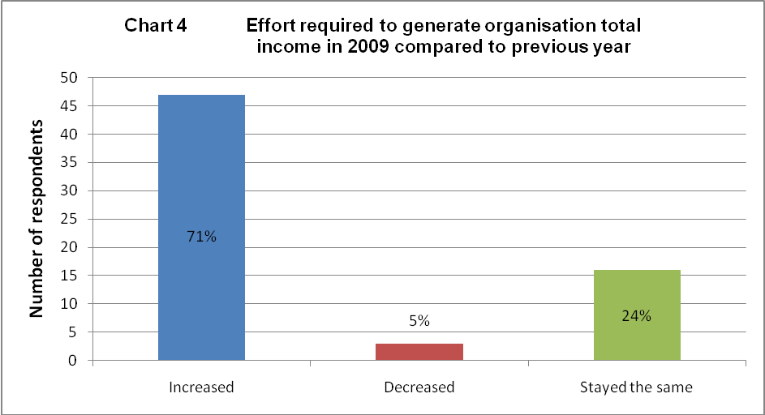

IMPACT ON THE DEMAND FOR THE ORGANISATION SERVICE
As findings have shown, voluntary disability organisations have had to increase their efforts to raise their own income because statutory and non-statutory funding sources have decreased. At the same time, they are coming under increasing pressure because the demand for their services has actually increased as shown in the chart below. The main reason attributed to this increase is the promotion of their service through fundraising campaigns, which in some ways puts more pressure on the organisation to raise even more money and meet the need for their service.

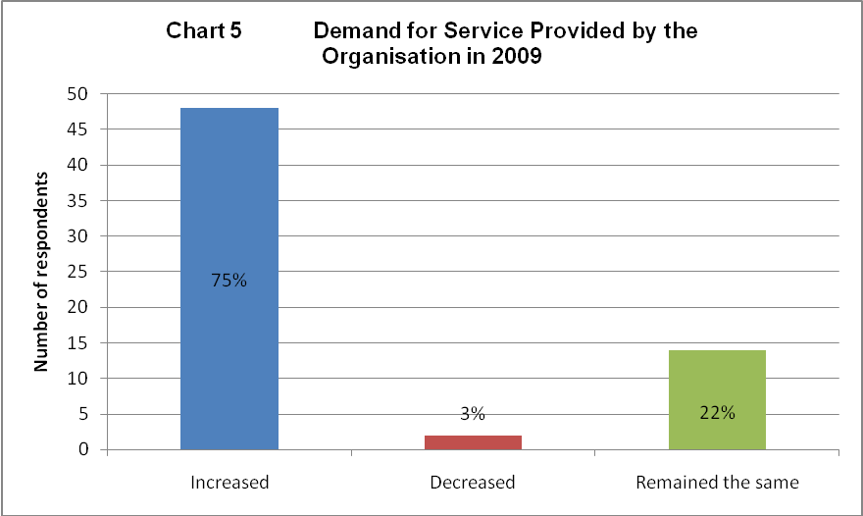

OPPORTUNITIES PROVIDED BY THE RECESSION
Members were asked what opportunities the economic downturn had provided. The responses were varied but demonstrated the value in organisations taking the time to reflect on their position in the new environment. Organisations were particularly positive about the opportunity to negotiate better prices for their goods and services. There was also reference to greater cooperation from staff during a time of recession and for increasing efficiency within the organisation.

“Services and goods are available at better prices. We are now negotiating with all providers for their prices on services”

“Prices of property have dropped”

“More efficiency and cooperation from staff” (DFI member organisation)

The opportunity to reduce their overhead costs in 2009 compared to the previous year was further explored in a direct question. The answers shown in the Chart below demonstrate that 9 out of 10 respondents agreed with the statement that they had reduced their overhead costs in 2009.

Chart 6 We have reduced our costs in 2009
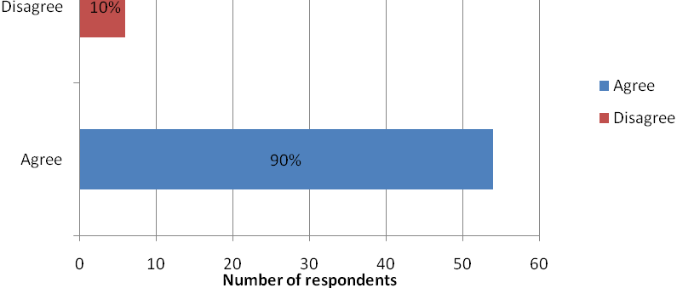

Other opportunities that have arisen as a result of the economic downturn included the new opportunities to collaborate. This was considered within the context of improving their overall service.
“We are more focused on improving what we do with services available to us. We are having discussions with other agencies about collaboration” (DFI member organisation)

Finally, organisations noted the increase in volunteers and the chance to review and re-position the organisation. In some instances, respondents reported that service users were now more understanding of the constraints on funding and challenges this posed.
“It’s easier to communicate change to clients because there’s a greater awareness that things have to be done differently. The organisation is aware that they need to be cost effective and provide good value for money” (DFI member organisation)

CONCLUSION
The findings from the DFI survey demonstrate the extent to which voluntary disability organisation continue to support people with disabilities. It shows the value they have in the provision of direct health and social services that are funded through non-statutory as well as statutory sources of income. While opportunities provided by the recession were noted, there is evidence that disability services have been significantly affected by the economic downturn. More cuts were introduced in 2010 and it is likely that services have been further reduced. It is therefore critical that disabled people are protected in Budget 2011 and funding to voluntary disability organisations remain in tact.



DISABILITY FEDERATION OF IRELAND

Disability Federation of Ireland (DFI) is the national support organisation for voluntary disability organisations in Ireland who provide services to people with disabilities and disabling conditions

Hidden Intellectual
Mental Health Physical
Sensory Emotional

DFI works to ensure that Irish society is fully inclusive of people with disabilities and disabling conditions so that they can exercise fully their civil, social and human rights. In pursuit of this vision, DFI:
- Acts as an advocate for the voluntary disability sector
- Supports organisations to further enable people with disabilities
There are 123 organisations within membership or as associates of DFI. DFI also works with a growing number of organisations and groups around the country that have a significant disability interest, mainly from the statutory and voluntary sectors. DFI provides:
Information Organisation and Management Development
Training and Support Advocacy and Representation
Networking Research and Policy Development
DFI also supports the broader voluntary and disability sector through its representation of the disability strand within the Community and Voluntary Pillar of Social Partnership, as a social partner at the National Economic and Social Forum, Health Service Executive, Co-Ordinating Committees, and other fora at regional, national and European levels.

Disability Federation of Ireland, Fumbally Court, Fumbally Lane, Dublin 8
Phone: 353-1- 454 7978 Fax: 353-1- 454 7981
Email: info@disability-federation.ie

